**UNIVERSITY “POLITEHNICA” OF BUCHAREST**

**FACULTY OF ENGINEERING IN FOREIGN LANGUAGES**

**ELECTRONIC, TELECOMMUNICATION AND INFORMATION TECHNOLOGY – ELECTRONIC ENGINEERING**

**SUMMER**

**INTERNSHIP**

**Tutor:**

**S. L. Dr. Ing. Iuliana MARIN**

**Supervisor Teacher:**

**S. L. Dr. Ing. Ioana GUICA**

**Student:**

**Mihaela STROE**

**Bucharest**

**2022**

**UNIVERSITY “POLITEHNICA” OF BUCHAREST**

**FACULTY OF ENGINEERING IN FOREIGN LANGUAGES**

**ELECTRONIC, TELECOMMUNICATION AND INFORMATION TECHNOLOGY – ELECTRONIC ENGINEERING**

**Intelligent Bracelet**

**(Communication Based on the MQTT Protocol)**

**Tutor:**

**S. L. Dr. Ing. Iuliana MARIN**

**Supervisor Teacher:**

**S. L. Dr. Ing. Ioana GUICA**

**Student:**

**Mihaela Stroe**

**Bucharest**

**2022**

**Tabel of Contents**

[**1.**](#_heading=h.gjdgxs) **Introduction** 4

[**1.1**](#_heading=h.30j0zll) **Background** 4

[**1.2**](#_heading=h.1fob9te) **Motives** 5

[**1.3**](#_heading=h.3znysh7) **Advantages** 5

[**2.**](#_heading=h.2et92p0) **State – of – the – art** 6

[**2.1**](#_heading=h.tyjcwt) **Related works** 6

[**2.2**](#_heading=h.1t3h5sf) **SWOT** 6

[**3.**](#_heading=h.4d34og8) **Proposed solution** 6

[**3.1**](#_heading=h.2s8eyo1) **Description** 6

[**3.2**](#_heading=h.17dp8vu) **Actors** 6

[**3.3**](#_heading=h.3rdcrjn) **Functionalities (use cases)** 6

[**3.4**](#_heading=h.26in1rg) **Sequence diagrams** 6

[**4.**](#_heading=h.lnxbz9) **Testing** 6

[**4.1**](#_heading=h.35nkun2) **Test each use case (code, results)** 6

[**5.**](#_heading=h.1ksv4uv) **Conclusion and Future Work** 6

[**6.**](#_heading=h.44sinio) **References** 6

1. **Introduction**

## **Background**

Health problems are now the daily cause of increasing numbers of deaths in the majority of nations. 55.3 million deaths per year are attributed to delays in provided appropriate care or a lack of care as a result of a shortage of medical staff or resources, particularly in rural hospitals. As a result, there is a need for some solutions to this problem.

Since smartphones have grown more widely used in recent years, more consumers have welcomed technology items that use artificial intelligence (AI). However, there it isn’t much information available on the use of intelligent bracelets to improve people’s health.

Even if the intelligent bracelet is not a brand – new development in the world of wearable computing, its selection has recently increased.

An intelligent bracelet is a piece of clothing that records all of the user’s physical activity.

Typically, an application that is included with the intelligent bracelet allows you to read the data it has collected directly on your smartphone.

You will then know exactly how many steps you took over a certain period of time and how calories you consumed, in addition to your level of oxygenation and heart rate.

Every aspect of your sleep, including its quality, is rigorously examined and studied by your intelligent bracelet. As soon as you get into bed, simply activate the features that allow you to keep an eye on your sleep.

Therefore, rather of acting as a sports coach, your intelligent bracelet acts as a tool that motivates you to keep a healthy lifestyle. It encourages you to stand up and continue moving.

* 1. **Motives**

First things first, a lot of consumers need to exercise. The intelligent bracelet keeps track of daily activity levels and caloric consumption. It is possible to make sure that one consumes the recommended number of calories each day.

Second, intelligent bracelets can monitor sleep. It works as an alarm clock in the mornings. You can evaluate how well you sleep while eating breakfast. People will find easier to form a disciplined habit as a result of this.

Thirdly, since intelligent bracelets can track our blood oxygenation and heart rate, they can help us maintain our health.

* 1. **Advantages**

The smart bracelet is a brand - new smart wearable with a number of benefits that make it a terrific option for many people, particularly smart wearable enthusiasts.

**Motion Detecting**

**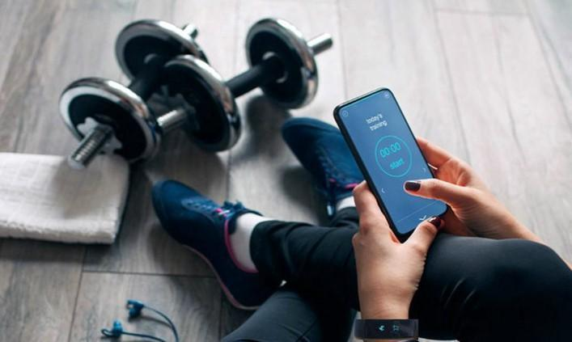**

**Fig. 1. Motion Detecting [1]**

An advanced pedometer that tracks steps can be compared to an intelligent bracelet. It is possible to track the number of steps thanks to flash memory and built – in three – axis smart acceleration sensors. In order to calculate and report the completion rate, the recorded steps by the intended steps can also be employed.

Calorie tracking is the practice of recording calories consumed. Smart bracelets can compute calories by measuring steps and estimating calories burned based on workout data.

* **Heart Rate Detecting**

**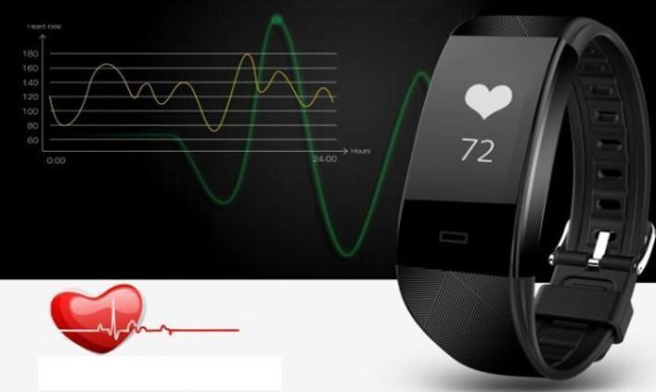**

**Fig. 2. Heart Rate Detecting [1]**

In order to help you track your fitness, intelligent bracelets can measure your heart rate, blood pressure and blood oxygen saturation. This detection is finished as determined by the measurement of photoelectric transmission.

Thanks to an embedded reflective photoelectric sensor that can project a beam of light (typically LED light) onto your skin, the intelligent bracelet can observe the capillary veins in your wrist. The blood can then absorb the specific wavelength of this light. The sensor measures the light that is reflected you’re your body and counts the heartbeat to determine your beating.

The information about your basic health issues and subsequent instructions for improving them will be provided in a data format and synced with the appropriate software on your smartphone or tablet when the heartbeat has been detected.

* **Sleep Monitoring**

**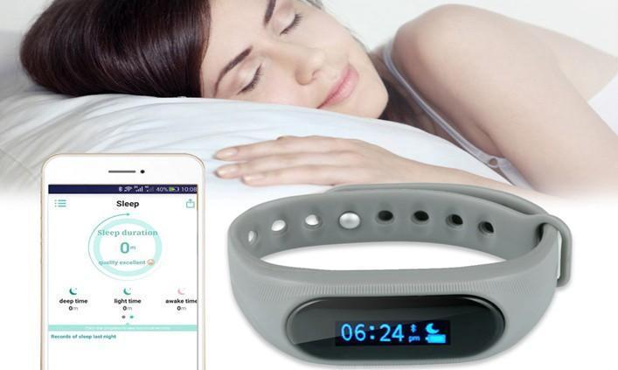**

**Fig. 3. Sleep Monitoring [1]**

Due to their habit of staying up late in the smartphone era, many people have poorer – quality sleep. Smart bracelets’ sleep monitoring feature is quite helpful for improving sleep quality and wake – up times.

The results of these detections will then be shown to you in the form of data and evem in the form of sleep tendency charts, which will aid in your understanding and help you sleep better. Since many people struggle to get quality sleep, several intelligent bracelets highlight this feature as a selling point.

1. **State – of – the – art**
   1. **Related works**

Given that smart bracelets are being used more and more nowadays and that many improvements are being made with them every day, such as that they can determine the early stages of important diseases (such as: Alzheimer (Al-Naami B, Abu Owida H, Abu Mallouh M, Al-Naimat F, Agha M, Al-Hinnawi AR. A New Prototype of Smart Wearable Monitoring System Solution for Alzheimer’s Patients. *Med Devices (Auckl)*. 2021;14:423-433 <https://doi.org/10.2147/MDER.S339855>), COVID-19 (Bin Fang, Fuchun Sun, Zhou Quan, Huaping Liu, Jianhua Shan, "Smart Bracelet System for Temperature Monitoring and Movement Tracking Analysis", *Journal of Healthcare Engineering*, vol. 2021, Article ID 8347261, 11 pages, 2021. <https://doi.org/10.1155/2021/8347261>; Caleb Mayer, Jonathan Tyler, Yu Fang, Christopher Flora, Elena Frank, Muneesh Tewari, Sung Won Choi, Srijan Sen, Daniel B. Forger,Consumer-grade wearables identify changes in multiple physiological systems during COVID-19 disease progression,Cell Reports Medicine,

<https://doi.org/10.1016/j.xcrm.2022.100601.(https://www.sciencedirect.com/science/article/pii/S2666379122001185)>; [Smartwatch can detect early signs of illness | News Center | Stanford Medicine](https://med.stanford.edu/news/all-news/2020/12/smartwatch-can-detect-early-signs-of-illness.html); JOUR, Mishra Tejaswini, Wang Meng, Metwally Ahmed A., Bogu Gireesh K., Brooks Andrew W., Bahmani Amir, Alavi Arash, Celli Alessandra, Higgs Emily, Dagan-Rosenfeld Orit, Fay Bethany, Kirkpatrick Susan, Kellogg Ryan, Gibson Michelle, Wang Tao, Hunting Erika M., Mamic Petra, Ganz Ariel B., Rolnik Benjamin, Li Xiao, Snyder Michael P., 2020, 2020/12/01, Pre-symptomatic detection of COVID-19 from smartwatch data, Nature Biomedical Engineering,ttps://doi.org/10.1038/s41551-020-00640-6), cold ([Wearable Health Technology Can Detect Illness Before Symptoms Begin (verywellhealth.com)](https://www.verywellhealth.com/wearable-health-technology-detect-illness-5204814)), pain management (Nwosu AC, Quinn C, Samuels J*, et al*Wearable smartwatch technology to monitor symptoms in advanced illness*BMJ Supportive & Palliative Care* 2018;**8:**237.[Wearable smartwatch technology to monitor symptoms in advanced illness | BMJ Supportive & Palliative Care](https://spcare.bmj.com/content/8/2/237)), body fat percentage ([Amazon Halo Is First Wearable to Calculate Body Fat Percentage (verywellhealth.com)](https://www.verywellhealth.com/amazon-halo-health-body-fat-percentage-5076811)), temperature monitoring and movement tracking (Bin Fang, Fuchun Sun, Zhou Quan, Huaping Liu, Jianhua Shan, "Smart Bracelet System for Temperature Monitoring and Movement Tracking Analysis", *Journal of Healthcare Engineering*, vol. 2021, Article ID 8347261, 11 pages, 2021. <https://doi.org/10.1155/2021/8347261>; Fang, Bin & Sun, Fuchun & Zhou, Quan & Liu, Huaping & Shan, Jianhua. (2021). Smart Bracelet System for Temperature Monitoring and Movement Tracking Analysis. Journal of Healthcare Engineering. 2021. 1-11. 10.1155/2021/8347261.), blood tests results prediction ([Smartwatch data can predict blood test results, study reports | News Center | Stanford Medicine](https://med.stanford.edu/news/all-news/2021/05/smartwatch-data-can-predict-blood-test-results.html)), divers sickness ([Smart Watch That Detects Illnesses (healthline.com)](https://www.healthline.com/health-news/watch-tells-you-when-youre-getting-sick); [COVID's Unlikely Offspring: The Rise of Smartwatch as Illness Detector - IEEE Spectrum](https://spectrum.ieee.org/covid-byproduct-smartwatch-increasingly-illness-detector); [Research on COVID-detecting smartwatches still hasn’t panned out - The Verge](https://www.theverge.com/2022/4/25/23040869/covid-detecting-smartwatch-illness-fitbit-apple-watch); [Wearables can track COVID symptoms, other diseases | University of Michigan News (umich.edu)](https://news.umich.edu/wearables-can-track-covid-symptoms-other-diseases/); [Someday soon, smartwatches may know you’re sick before you do | Science News for Students](https://www.sciencenewsforstudents.org/article/innovation-smartwatches-early-sickness-detection)), human pose ([Design and Implementation of Smart Bracelets Mutual Authentication System (exeter.ac.uk)](https://hpcn.exeter.ac.uk/iucc2021/proceedings/pdfs/IUCC-CIT-DSCI-SmartCNS2021-40WP54zLa9Wagib9WOs48p/666700a146/666700a146.pdf))), they are an important step in the development of technology.

In the two related works are presented the main differences between two models of intelligent bracelets, being based on different algorithms, one of them having a very well developed algorithm for detecting atrial fibrillation, and the other being more of a personal assistant of the elderly.

These two models, having the presented differences, can be weighed and analyzed from the point of view of the algorithm, of the advantages and disadvantages and finally also the proposal of some solutions to be improved.

**Related work 1** – A new wristband equipped with an artificial intelligence algorithm to detect atrial fibrillation

**Related work 2** – Designing a Desirable Smart Bracelet for Older Adults

|  |  |  |
| --- | --- | --- |
|  | **Related work 1** | **Related work 2** |
| **Where it was used** | It was used to measure the sensitivity, specificity and accuracy of a recently developed smart wristband device that it is equipped with both photoplethysmographic (PPG) and single – channel electrocardiogram (ECG) systems and an AF – identifying,artificial intelligence (AI) algorithm, used in the short term. | It was used to enhance the life of elderly people. The bracelet acts as a personal assistant during the user’s everyday life, monitoring the health status and alerting him or her about abnormal conditions, reminding medications and facilitating the everyday life in many outdoor and indoor activities. |
| **How – algorithms** | The Amazfit Health Band 1S (Huami Technology, Anhui, China) is a wearable wristband device that combines a single-channel ECG recorder with a high-precision PPG optical sensor. The wristband synchronizes either periodically or actively with a smartphone application via a Bluetooth connection. The PPG signals are collected automatically by the photoelectric sensor on the inner side of the wristband, at a sampling frequency of 50 Hz. The ECG signals are collected via metal sensors on the outer and inner sides of the wristband for left- or right-handed individuals, respectively. The choice of whether to wear the wristband on the individual’s left or right hand is preset in the application. The sampling frequency for ECG was 250 Hz. When the user touches the outer metal area with the opposite hand, the wristband automatically initiates ECG recording. A single-lead ECG is recorded for 60 seconds each time the recording is initiated. For example, when the user wears the wristband on the left hand and the right hand is on the outer side of the ring, this is equivalent to limb lead I (hereafter referred to as "wristband ECG").  The RealBeats Artificial Intelligence Biological Data Engine (Huami Technology) was developed using a deep convolution neural network (SEResNet), trained by 21,618 tagged ECGs (4734 of which were AF cases) and a test set of 8518 tagged sources of ECG data (241 of which were AF cases). The sensitivity and specificity of the test set were 93.36% and 99.75%, respectively. Training and testing of the AI algorithm are discussed in [Supplemental Material 1](https://www.sciencedirect.com/science/article/pii/S1547527120300898" \l "appsec1).  The PPG signal was acquired for 71 seconds. If the built-in algorithm detected a suspected AF, the 71-second PPG signal was repeated to determine whether the AF would be identified again. The final output of the algorithm was "AF" if 2 consecutive tests within 3 minutes were judged as "AF." If the first or repeated determinations were "not AF" rhythms, the output of the algorithm was "not AF." If signal quality was too poor or requirements to make a determination were not met, the output was "unable to judge." The peak-to-peak interval data were transmitted to the smartphone application via Bluetooth, providing original data. The wristband recorded ECG signals for 60 seconds after the device was triggered by touching of its outer electrode. If contact with the electrode was disconnected during the acquisition process, the recording stopped and was restarted. After notch filtering and moving-average baseline filtering, the ECG waveform signal data were transmitted to the smartphone application via Bluetooth. ECG data were transmitted to an Internet server using a smartphone for AI algorithm-mediated determinations. | Bright and Coventry suggest providing diversionary features in order to draw away the attention from the medical purpose of the assistive device. To this purpose we propose a set of functionalities that can enhance the user’s everyday life. We propose seven functionalities, which are depicted in Figure 4:   1. Digital payment for shopping 2. Digital payment for transportation 3. Health monitoring and alert (e.g., hydration) 4. Health data storage, for facilitating healthcare diagnosis 5. Message notification from the smartphone 6. Multimodal interaction with home appliances 7. Reminder   The first two features facilitate outdoor activities like shopping and taking transportations thanks to a digital payment system. Promoting outdoor activities has several benefits: older adults can have an active social life and the correlated physical activity is able to cope with the sedentary lifestyle typical of some older adults. Both have been proven to improve health and cognitive status of older adults [23]. Associating the smart bracelet to health and vitality is definitely a “counter- stereotypes” that can boost self-esteem and facilitate the acceptance of this assistive technology. Therefore, also the health monitoring features could be associated to a more active life, rather than to a negative valence: by wearing the smart bracelet the user could feel safer and more confident, even during outdoor activities. The health data storage could generate privacy concerns, thus, the user should have the possibility to disable the log of health data. Moreover, only authorized medical staff should be allowed to read and analyze those data. The message notification from the smartphone is a particularly useful feature for older adults with hearing impairments. Ageism will not be triggered, because it is a common feature that is present in many wrist-worn devices, very useful also for younger people.  Multimodal interaction with smart appliances is a feature that aims at improving the indoor life of elder people, by making the interaction with household appliances more natural and simplified [10]. The many advantages of multimodal interaction will be shown in the next section. The reminder is a generic alarm that could be associated to the smartphone calendar for important events or to a medication reminder. The latter is presented as optional because it could trigger ageism. |
| **Advantages** | * Uses ECG * AI algorithm * Easily detects atrial fibrillation | - Easy to use for the elderly as well as for younger people  - It helps the elderly to keep their health under observation in both outdoor and indoor activities. |
| **Disadvantages** | It doesn’t have in the algorithm the measurement of the oxygen level. | The algorithm of this intelligent bracelet is good for the elderly or young people, but it is not generally useful for an intelligent bracelet. |
| **Proposed solution** | To add in the algorithm also the measurement of the oxygen level. | Implement an algorithm to find out the exact location of the user. |

* 1. **SWOT for existent solutions and for the proposed bracelet**

|  |  |
| --- | --- |
| **SWOT Analyse** | |
| **S - Strengths** | **W - Weaknesses** |
| * The intelligent bracelets’ interface and algorithm work in an easy way for the user. * The user will be taken as they don’t have past medical record. * We associate each “activity” in our intelligent bracelet with the actual medical activity. * The design will be easily understood by anyone. * Always making sure to have 100% accuracy in our data. * The intelligent bracelets’ interface is responsive in a short amount of time. * Notify the user 2 h before in case there will not be any battery left. | * World Health Organization does not recognise the accuracy of intelligent bracelet measurements. * Unknown buttons / functions. * Insufficient text or description. * Wrong translation. * Don’t let adds interfere in user activity of the bracelet or don’t have adds at all. * For the elderly, don’t ask about feedback. * Not tested on enough persons. * The bracelet can be placed improperly on the wrist. |
| **O - Opportunities** | **T - Threats** |
| * We can make the app work in a more effective way; to be used by kids and teenagers as well. * Build an app for kids and teenagers in which their bracelet is somehow connected to their parents’, so let the parent knows the kid or teenager health status and location. * Will monitor in a do – not disturb manner the users’ indoor and outdoor activity. | The well – known competitive intelligent bracelets market:   * Have much more experience – they already know how people interact and what exactly needs. * They have enough resources to promote their bracelets. * Have been tested on multiple people and for different situations (water flooding, particle intrusion etc.). |

1. **Proposed solution**
   1. **Description**

This project intends to create an IOT-based healthcare system that will gather many patient body parameters, analyze them for any abnormal values, and send the results to a server for storage. The vital data of the patient are collected using a variety of medical sensors.

Fig. 1 shows the key elements of the proposed healthcare system, which consists of the Esp8266 - 12F , Arduino UNO , and MQTT protocols. The Arduino UNO supports a wide range of peripheral connections; in this study, the peripherals stand in for a number of sensors including temperature, SPO2, and ECG/Pulse rate.

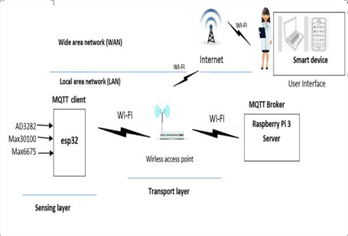

**Fig. 4 The overall system architecture [8]**

Numerous medical sensors can collect a variety of medical parameters, including heart rate, body temperature, blood pressure, breathing rate, and capillary oxygen saturation. The analog data that the sensor collects must be transformed into digital format for storage and transmission. The following sensors are used in the suggested model in this paper:

• AD8232 for monitoring a 3-channel ECG.

• MaX30100 for measuring spo2.

• Max6657 for measuring temperature.

* 1. **Actors**

Considering the fact that the proposed intelligent bracelet focuses on the health of patients, it can be addressed to both adults and the elderly.

* 1. **Functionalities (use cases)**

**Measurement of Heart Response and blood oxygenation**

The percentage of the maximal amount of oxygen that blood can transport that is measured by oxygen saturation (spo2). Max 30100's measurement of oxygen saturation is shown in fig. 5. The MAX30100 is the device that combines a sensor for measuring pulse oximetry with a heart rate monitor. The sensor was created to work with wearable technology. The sensor's operating principle is optical reflection, therefore it is equipped with two LEDs, a photodetector, and improved optics. In addition, it processes low noise analog data to produce accurate pulse rate and SPO2 outputs. the sensor used to collect data, by touching the sensor with your fingertips.

As illustrated in Fig. 5, the Max 30100 sensor and Esp8266 communicate with each other via the I2C communication protocol using their respective SDA and SCL pins.

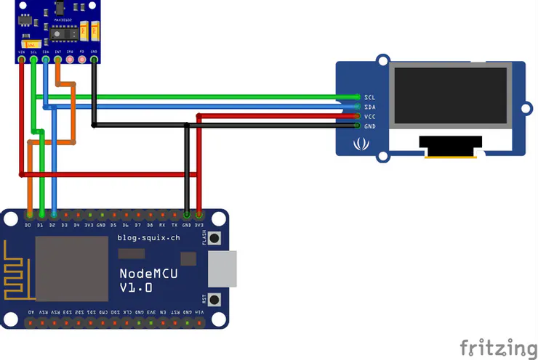

**Fig. 5 Interfacing between Max 30100 and ESP2866 [8]**

**Temperature Measurement**

The output voltage linearity of the LM35 temperature sensor, which has three pins (VCC, OUT and GND), is related to temperature in degrees Celsius. We require an ADC (Analog – to – Digital Converter) because the LM35 output varies with temperature. The ADC has one ADC module with a 10 – bit resolution. As demonstrated in fig. 6, setup the sensor with the esp8266.

**Fig. 6 Configuration of temperature sensor with ESP8266**

* 1. **Sequence diagrams**

**Use case Intelligent Bracelet**

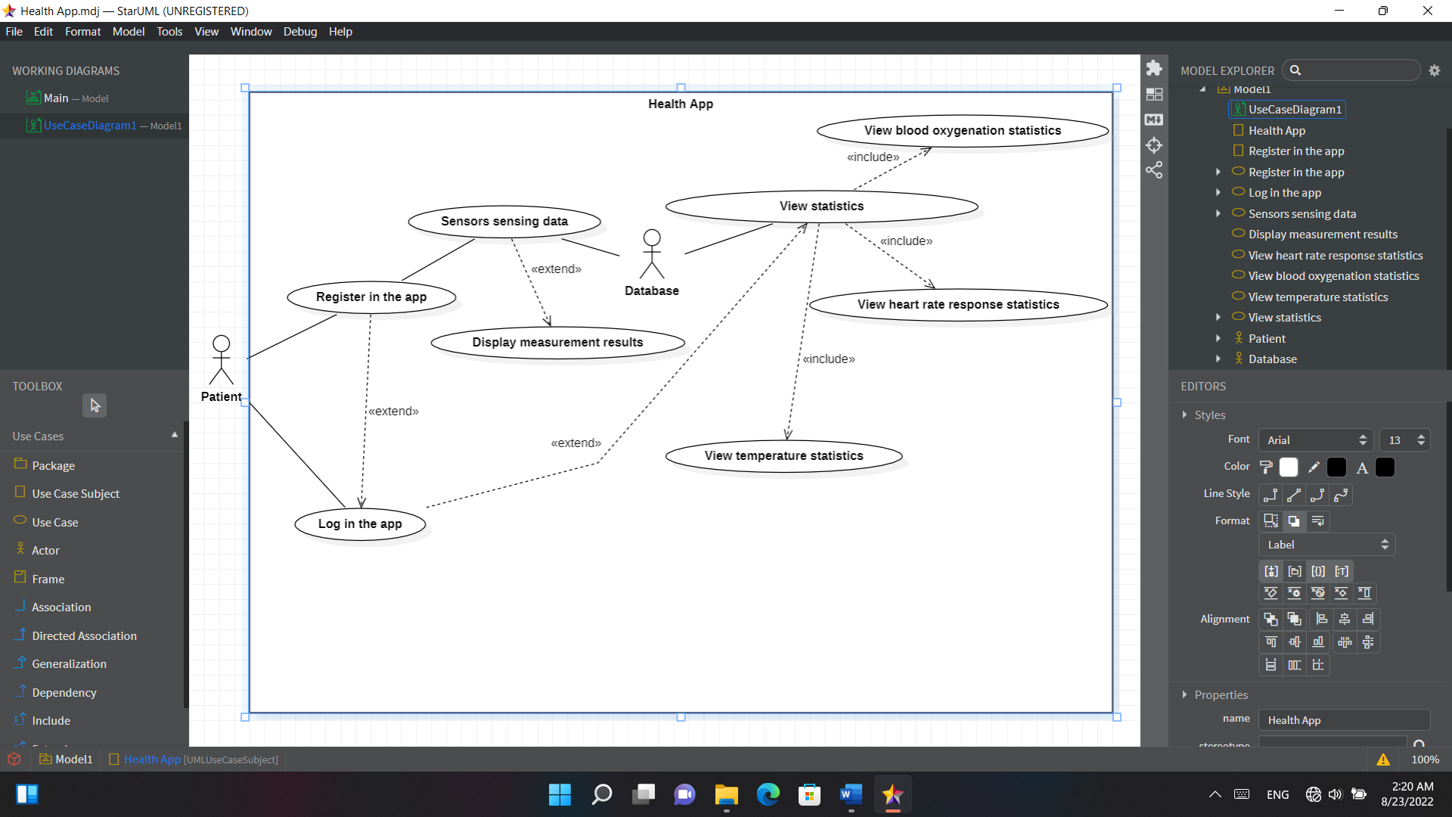

**Fig. 7 Use case diagram: Intelligent Bracelet and its use cases**

**Sequence diagram use case 1**

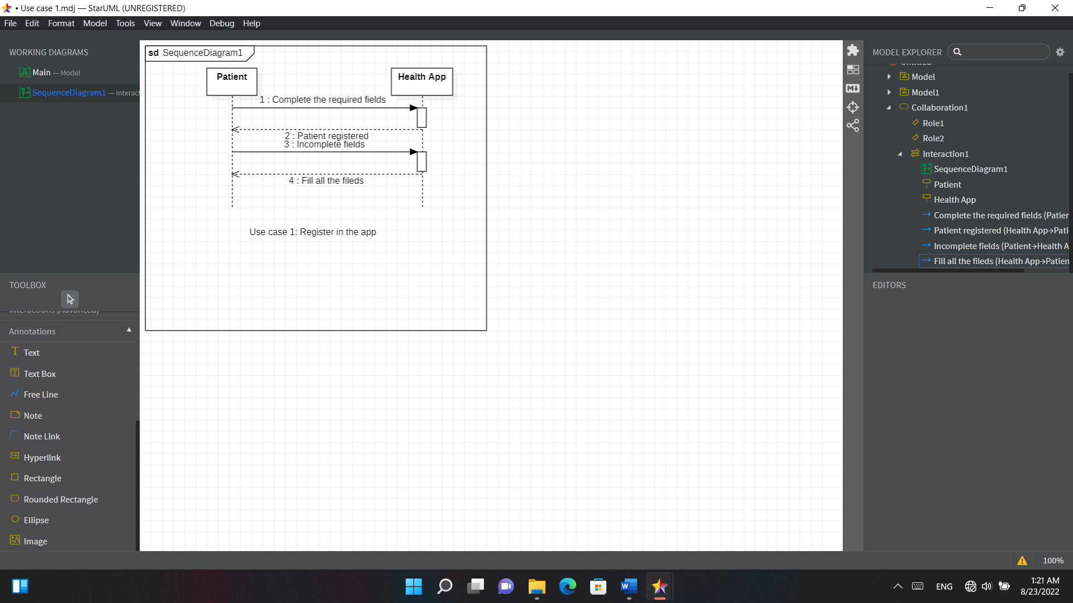

**Fig. 8 Sequence diagram use case 1: Register in the app**

**Sequence diagram use case 2**

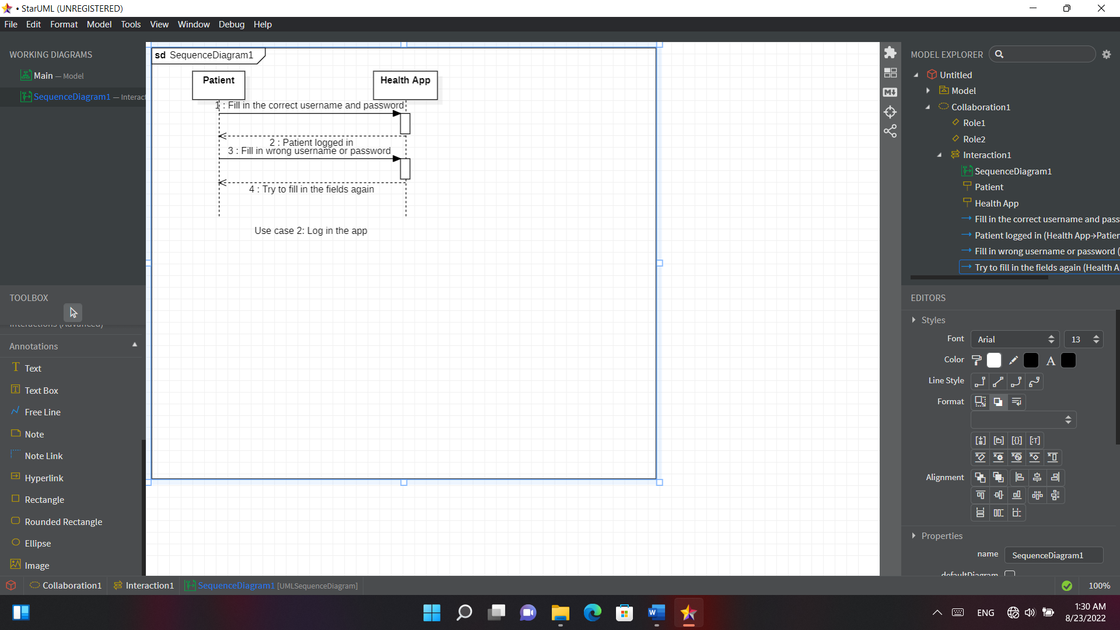

**Fig. 9 Sequence diagram use case 2: Log in the app**

**Sequence diagram use case 3**

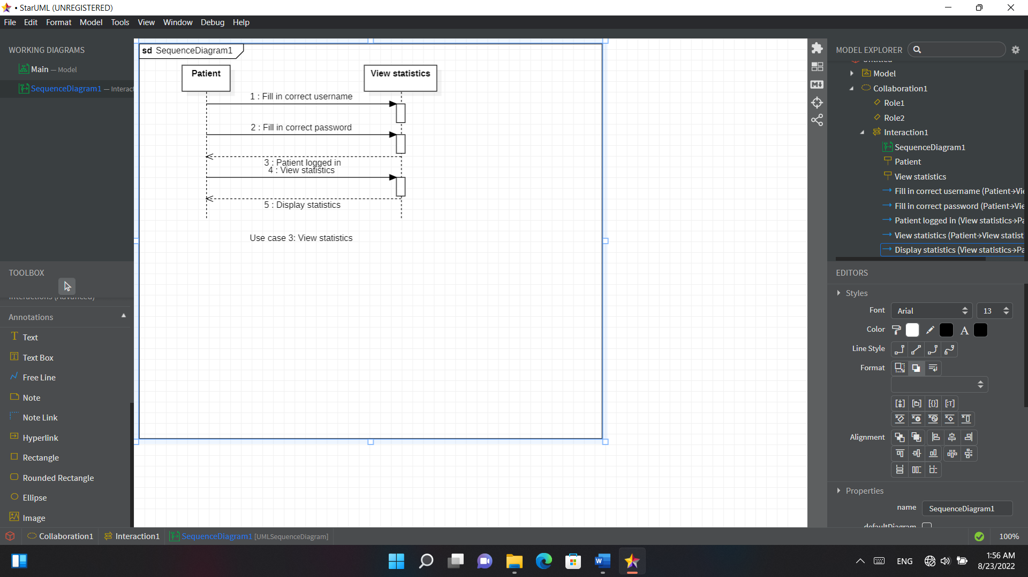

**Fig. 10 Sequence diagram use case 3: View statistics**

**Sequence diagram use case 4**

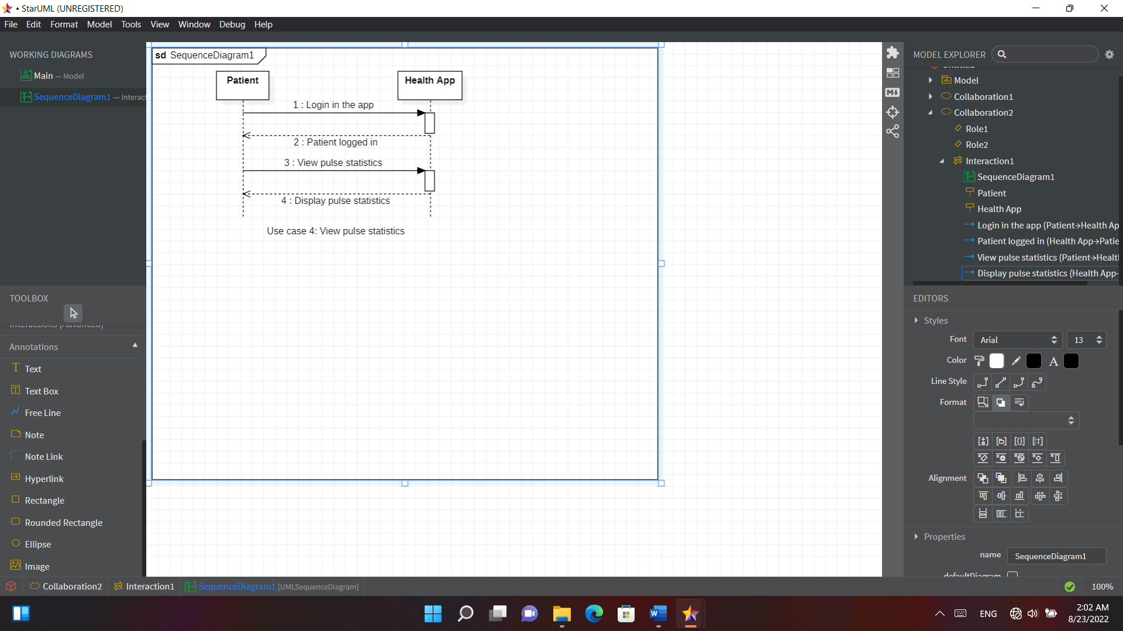

**Fig. 11 Sequence diagram use case 4: View pulse statistics**

**Sequence diagram use case 5**

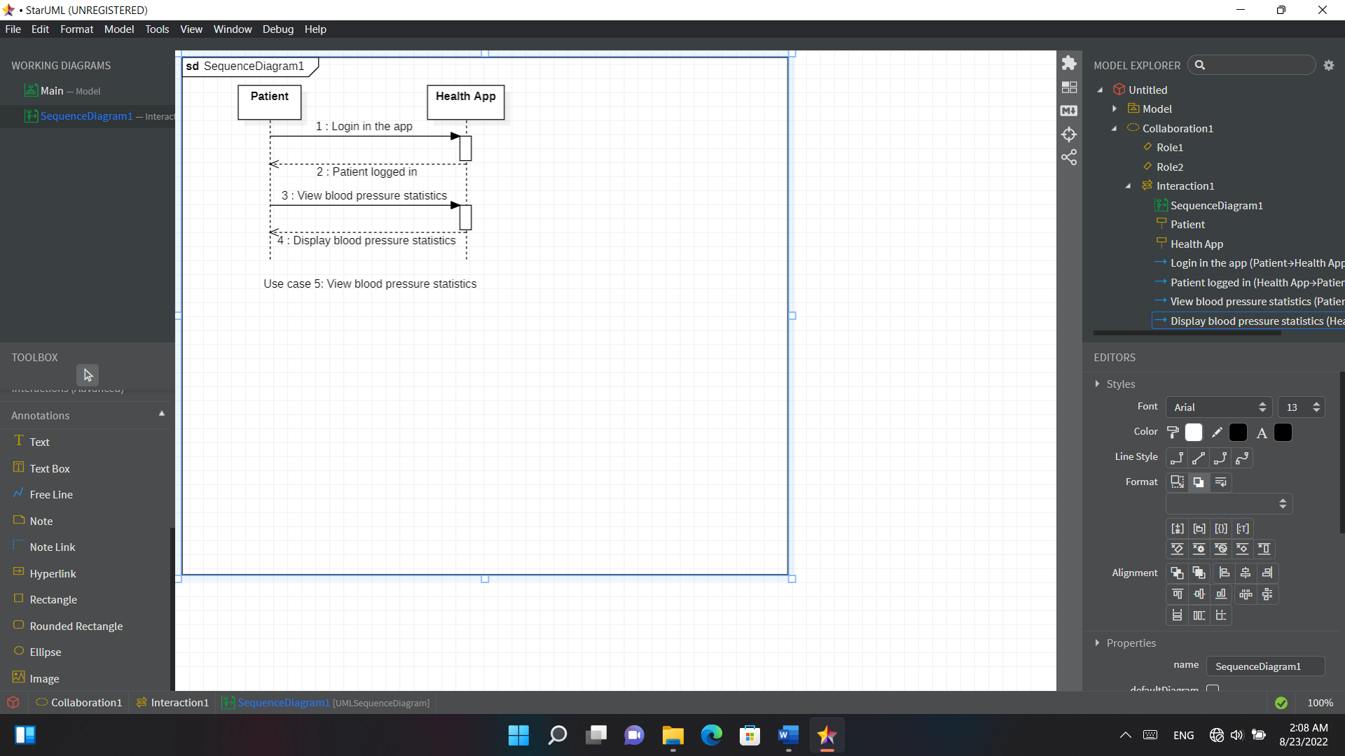

**Fig. 12 Sequence diagram use case 5: View blood pressure statistics**

**Sequence diagram use case 6**

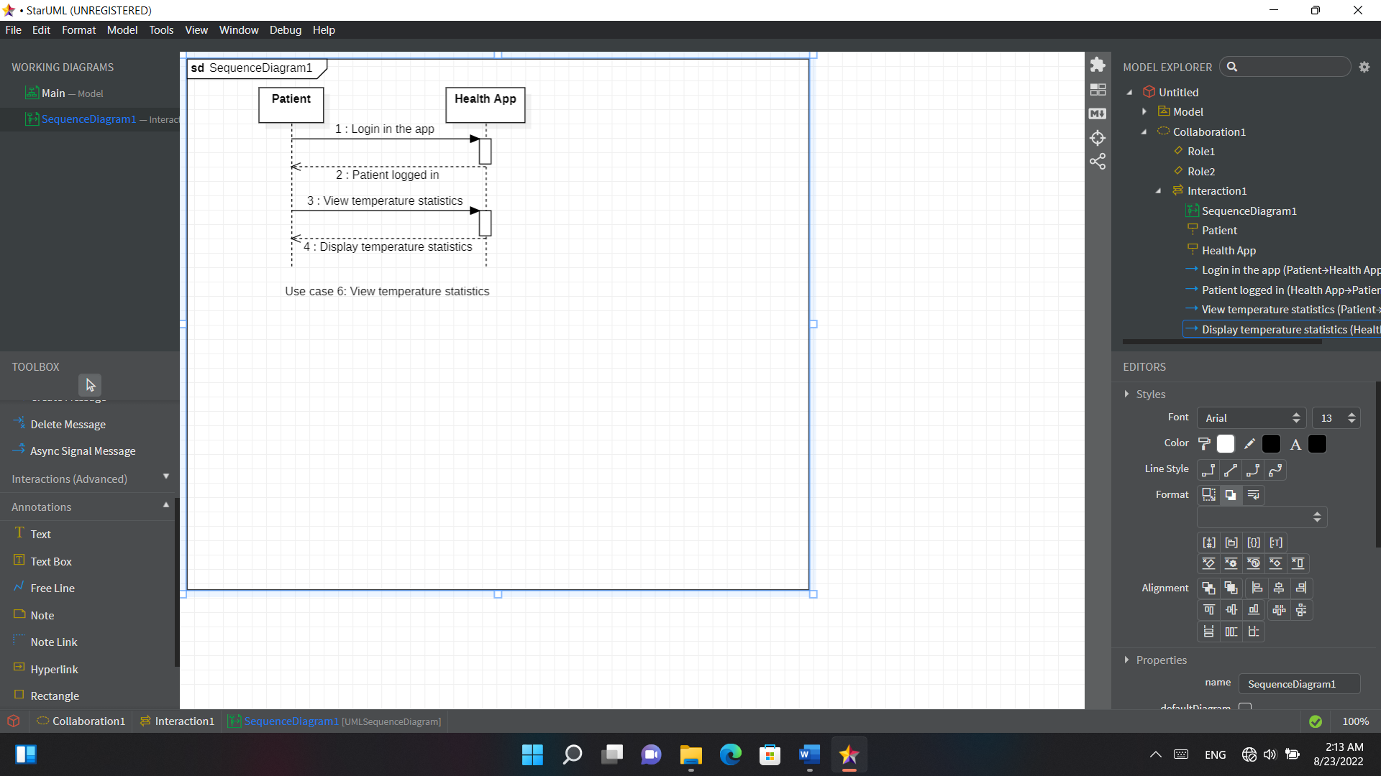

**Fig. 13 Sequence diagram use case 6: View temperature statistics**

1. **Testing**
   1. **Test each use case (code, results)**

**Hardware and Technology Used**

**NodeMCU ESP8266**

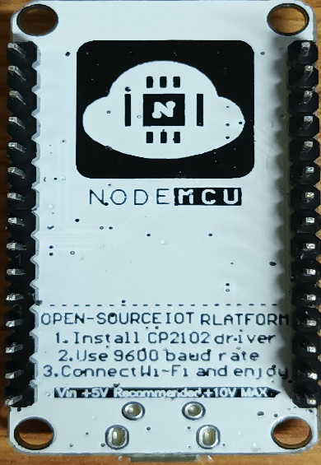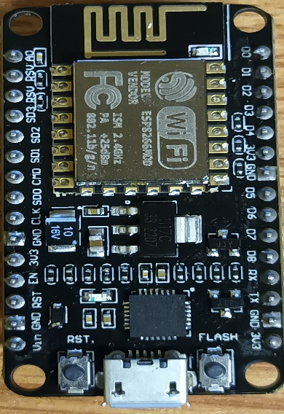

**Fig. 14 NodeMCU ESP8266**

The [NodeMCU](http://nodemcu.com/index_en.html" \t "_blank) (Node MicroController Unit) is an open source software and hardware development environment that is built around a very inexpensive System-on-a-Chip (SoC) called the [ESP8266](https://en.wikipedia.org/wiki/ESP8266). The ESP8266, designed and manufactured by [Espressif Systems](https://espressif.com/en/products/hardware/esp8266ex/overview" \t "_blank), contains all crucial elements of the modern computer: CPU, RAM, networking (wifi), and even a modern [operating system and SDK](http://bbs.espressif.com/).

**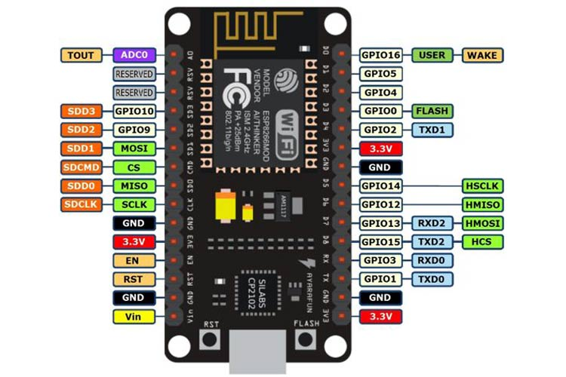**

**Fig. 15 NodeMCU ESP8266 pinout**

Through its pins we can read inputs - light on a sensor, a finger on a button, or a Twitter message -and turn them into an output - activating a motor, turning on an LED, publishing something online. It has also WiFi capabilities, so we can control it wirelessly and make it work on a remote installation easily! We can tell our board what to do by sending a set of instructions to the microcontroller on the board. To do so we can use the [the Arduino Software (IDE)](https://www.arduino.cc/en/Main/Software).

**Quick Start to NodeMCU ESP8266 on Arduino IDE**

Firstly open the Arduino Software (IDE).

Go to files and click on the preference in the Arduino Software (IDE).

**Fig. 16 Preferences Tab in Arduino Software (IDE)**

Copy the below code in the Additional Boards Manager:

<http://arduino.esp8266.com/stable/package_esp8266com_index.json>.

Click OK to close the Preferences Tab.

**Fig. 17 Boards Manager in Arduino Software (IDE)**

After completing the above steps, go to Tools and Board, and then select Board Manager.

**Fig. 18 esp8266 by ESP8266 Community in Boards Manager in Arduino IDE**

In the search bar, navigate to esp8266 by ESP8266 Community and install the software for Arduino.

Once all the above process been completed, we are ready to program our ESP8266 with Arduino Software (IDE).

**Arduino Software (IDE)**

To communicate from the ESP8266 to the system, you can use the following code:

**Fig. 19 An example of code that you can use for communication between NodeMCU ESP8266 and system**

Now you would need a way to listen to the port that the NodeMCU ESP8266 is connected to.

In order to find the port in Windows, you need to search for “Device Manager”.

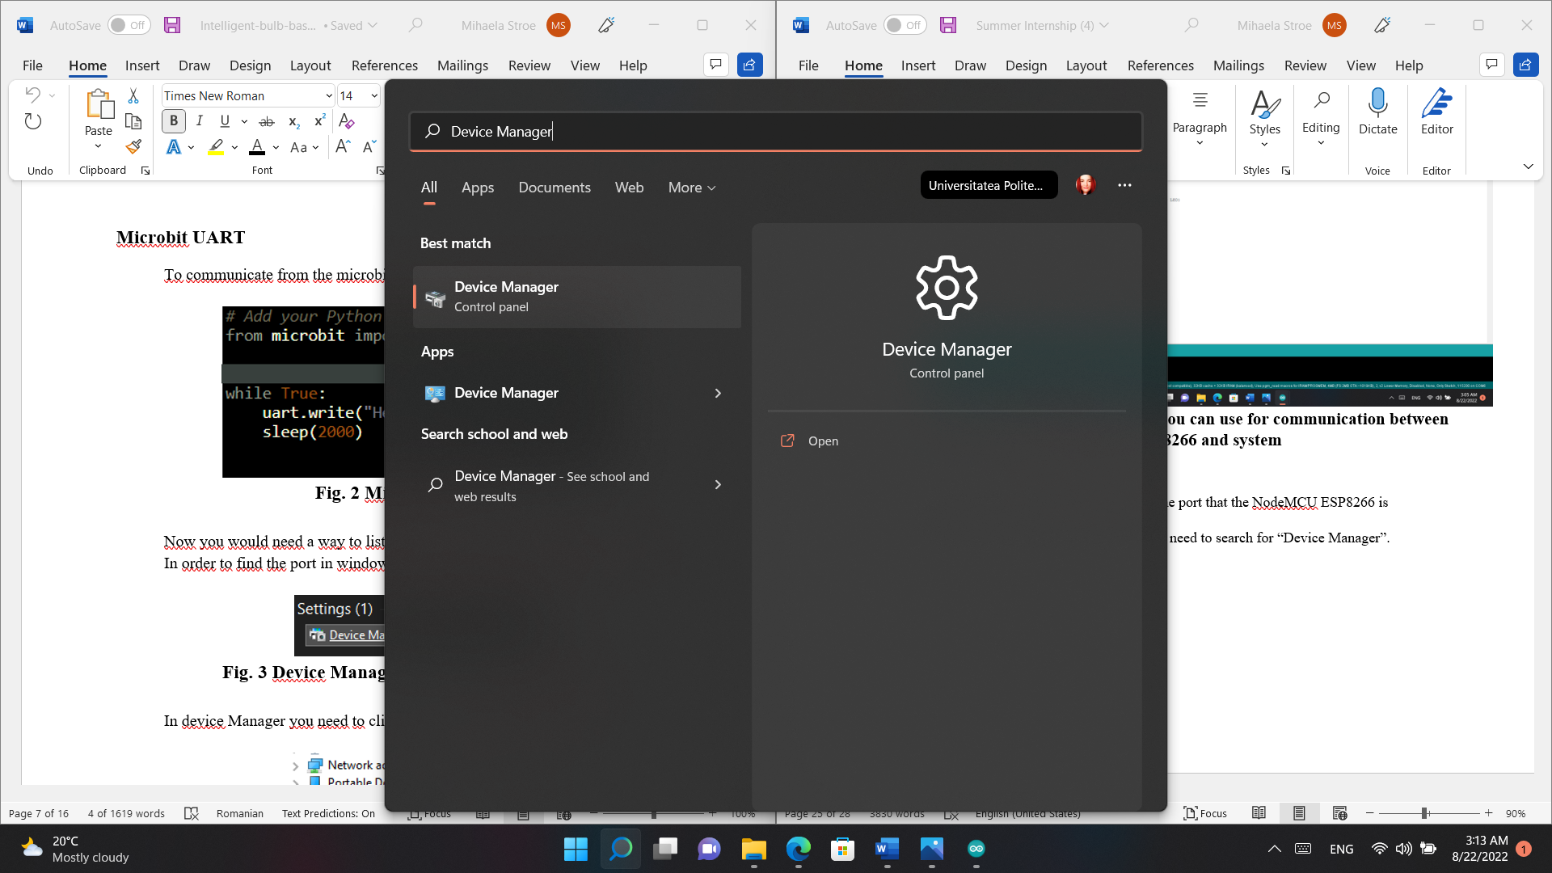

**Fig. 20 Device Manager in Windows search section**

In Device Manager you need to click on Ports and find the right one.

**Fig. 21 Ports in Windows Device Manager**

In my case its Silicon Labs CP210x USB to UART Bridge (COM6).

After you found the port, you need to find a way to connect to it. You can use Arduino IDE Editor.

Assuming you already have Arduino IDE installed, all you need to do is to add whatever code you want. For the demonstration purposes, I will use an example from File section, Example Tab on the Arduino IDE.

This is an example of how to connect to the NodeMCU ESP8266 via Arduino IDE:

**Fig. 22 Example of how to connect to the NodeMCU ESP8266 via Arduino IDE (ASCII Table)**

To note the parameter PORT is not necessary in order to open the port as the values displayed are the default ones.

If you run the code, the output would look like this:

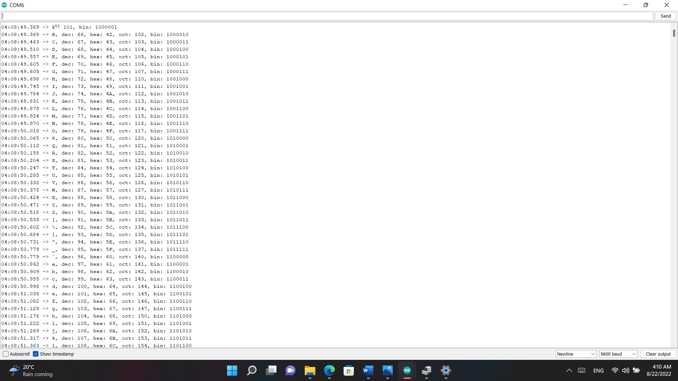

**Fig. 23 The output of the code**

**MQTT Protocol**

A lightweight open messaging protocol called MQTT (MQ Telemetry Transport) gives network connections with limited resources an easy way to share telemetry data in low – bandwidth settings. For machine – to – machine (M2M) communication, the MQTT protocol, which employs a publish / subscribe communication structure, is utilized.

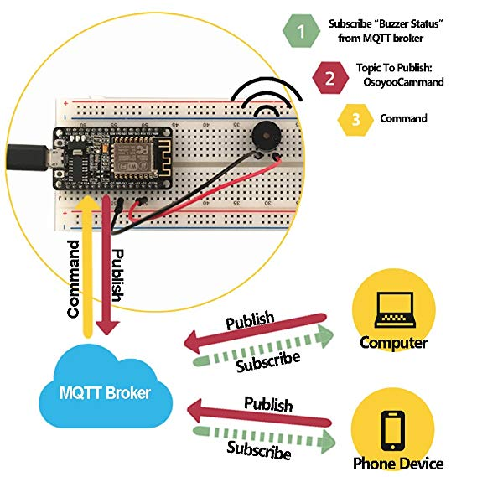

**Fig. 24 MQTT Protocol**

For the code we will use Arduino IDE with ESP8266WiFi and PubSubClient libraries.

To install them, we use the same method explained in the Quick Start to NodeMCU ESP8266 on Arduino IDE part.

**Fig. 25 ESP8266WiFi and PubSubClient libraries installed**

You will need to pick a broker. You can host one, but for this example I will use a free online broker.

After you have selected your broker, you will need to name your SSID (name of your mobile hotspot or WiFi Router), in my case Galaxy A22 5G (mobile hotspot) and then your mobile hotspot or WiFi password.

After this you can publish message with the publish function. It takes two parameters, first being the topic and the second being the message you want to send.

**Fig. 26 Connection to the MQTT Broker**

This picture would be the receiving end, as you can see in the void reconnect loop, we start listening to the subscribed topic.

The output:

**Fig. 27 Arduino IDE publisher and subscriber output**

1. **Conclusion and Future Work**

As an IoT system can read temperature, blood oxygenation, and heart reaction from anywhere, I proposed in this work a system for monitoring temperature, blood oxygenation, and heart response using the MQTT protocol in real-time.

Due to the low MQTT bandwidth and low power consumption, the system, which was created using an esp2866 and an Android UNO, has an acceptable efficiency and is relatively inexpensive.

The system can be developed and expanded in the future by adding additional sensors that use the MQTT protocol to identify emotions.

1. **References**

**Advantages – images:**

**[1]** [Smart Bracelet: What Does This Smart Wearable Gadget Do | by Carrie Tsai - Neway | Medium](https://carrienewaymobile.medium.com/smart-bracelet-what-does-this-smart-wearable-gadget-do-5f69b88f48ad)

State – of – the – art – Related works:

**[2]** life.pdf (accessed on July 12, 2022).

**[3]** Isaksen, J.L., Baumert, M., Hermans, A.N.L. et al., “Artificial intelligence for the detection, prediction, and management of atrial fibrillation”, Herzschr Elektrophys, vol. 33, pp. 34–41 (2022). <https://doi.org/10.1007/s00399-022-00839-x>

**[4]** Al-Naami B, Abu Owida H, Abu Mallouh M, Al-Naimat F, Agha M, Al-Hinnawi AR. A New Prototype of Smart Wearable Monitoring System Solution for Alzheimer’s Patients. *Med Devices (Auckl)*. 2021;14:423-433

<https://doi.org/10.2147/MDER.S339855>

**[5]** Caleb Mayer, Jonathan Tyler, Yu Fang, Christopher Flora, Elena Frank, Muneesh Tewari, Sung Won Choi, Srijan Sen, Daniel B. Forger,Consumer-grade wearables identify changes in multiple physiological systems during COVID-19 disease progression,Cell Reports Medicine,<https://doi.org/10.1016/j.xcrm.2022.100601.(https://www.sciencedirect.com/science/article/pii/S2666379122001185)>

**[6]** [Wearable Health Technology Can Detect Illness Before Symptoms Begin (verywellhealth.com)](https://www.verywellhealth.com/wearable-health-technology-detect-illness-5204814)

**[7]** [Smartwatch can detect early signs of illness | News Center | Stanford Medicine](https://med.stanford.edu/news/all-news/2020/12/smartwatch-can-detect-early-signs-of-illness.html)

[8] [Design Health care system using Raspberry Pi and ESP32 (ijcaonline.org)](https://www.ijcaonline.org/archives/volume177/number36/alsahi-2020-ijca-919863.pdf)